**REACT FUNDAMENTALS**

WHAT IS REACT??

1. Open-source JS library for building user-interfaces.
2. Not a framework.
3. Created and maintained by Facebook

Why React?

1. Huge community behind React (in StackOverflow)
2. Component-based architecture.
3. Re-usable code. (Components can be used multiple times.)

Pre-requisites?

HTML, CSS, JS, ES6 Fundamentals.

CREATE NEW REACT APP:

Install Node js & VS code (any text editor)

Use “create-react-app” command line interface tool for creating react app.

npx create-react-app project-name

Go inside your newly created project folder & run npm run start.

There are 2 ways to create react project:

Using npx & using npm:

In npx approach we don’t need to install the create-react-app package.

In npm, we install the package globally then use to generate the project.

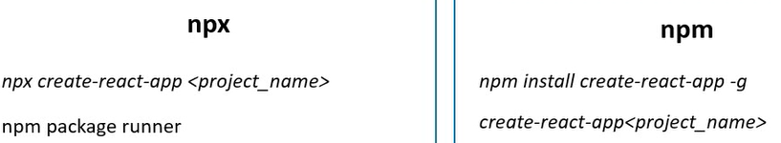

FOLDER STRUCTURE:

We get kind of this folder structure. 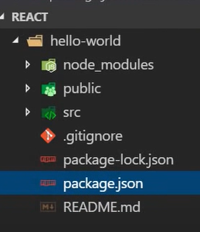

Index.html is only html in the app.

COMPONENTS:

A part of UI is a component.

Building-block of any react application.

Components are re-usable; a same component can be used to display different info by passing different properties.

Components can contain other components.

Two types of components:

Functional Components

Class Components

FUNCTIONAL COMPONENTS:

they are JS functions can optionally receive props(properties) and return HTML describing UI.

FUNCTIONAL COMPONENT

Props (properties) HTML (JSX)

Const FuncComp = (props) => {

return <h1>”Hi”</h1>

}

You can call <Greet></Greet> component like this.

Two types of exporting components:

Default export & named export

Default export: When we export a component using “export default component-name”. Then we can import that component using any name without curly braces.

Named export: When we export a component using named, each exportable entity is explicitly named. We have to import the component with exact same name.

CLASS COMPONENTS:

A class having optional props as input and returning JSX as output.

A class component should extend class “Component”.

The class should implement render method returning JSX or null.

Class MyClassComponent extends Component {

render (){

return <h1>hi</h1>

}

}

JSX:

JavaScript XML